Lutheran Women in Mission

30th Ohio District Biennial Convention
Canton, Ohio

. . . . . . . .

June 21-22, 2024

Lutheran Women in Mission
of the Akron-Youngstown Zone
invites you to join us at the…

30th Ohio District Biennial Convention
Friday, June 21–Saturday, June 22, 2024
in Canton, OH

Convention Theme
“The Lord is My Strength and My Shield”
Psalm 28:7a

Convention Logo Explanation

The Lord is my strength and my shield (Psalm 28:7a); in Him my heart trusts, and I am helped; my heart exults, and with my song I give thanks to him.

With God’s love, the figure has the strength needed to bear the weight of life. Our value to the Lord is manifested through the gold shield of His protection. The white cross is our Lord, which is as pure as His promise. We each bear the purple heart of prayer when we petition God’s forgiveness, His love strengthens and shields us.

Karen Shanahan, designer
Toledo Zone

To register for the Servant Events and Interest Sessions, please see the back of the registration form (can be downloaded from lwmlohio.org or can be found in the Spring ODE), mark your choices and return with your registration and medical forms.

FRIDAY SERVANT EVENTS

Lutheran Braille Workers (LBW)
Lbwloveworks.org
Help LBW assemble braille and large print devotionals, bible studies or something similar.

Heart of Ohio Diaper Bank
Heartofohiodiaperbank.org
Assemble feminine hygiene period kits to be distributed to the needy.
Cards to Seminary & Deaconess Students
Write a few words of encouragement to our future pastors and deaconesses.

FRIDAY INTEREST SESSIONS

Beth Marth, LWML Gift Planning Advocate

The LWML Gifts of Love program provides FREE benefits, including estate planning and updating estate documents. Participants will receive a guidebook, Passing On Your Faith-Wishes-Instructions, which walks one through key information the family will need when the Lord calls us home. They will also receive a sample Christian Preamble and Family Blessing.

Deaconess Janet Nicol, Phone Counselor
Word of Hope – A ministry of Lutherans for Life

This vital ministry helps hurting souls learn and receive the
LORD as their help and shield. Word of Hope provides spiritual care to men, women, and children experiencing overwhelming guilt, regret, grief, and conflict regarding a life issue decision, through the use of a hotline.

Human Care Committee
An additional servant event opportunity

Write words of encouragement to Ohio District pastors. The cards will be provided.

SATURDAY INTEREST SESSIONS

Heart to Heart Sisters of All Nations
Heba Beshai and Dorene Henschen, LWML Ohio District Leaders

Learn about this program and its importance to LWML. Hear about cultures in different parts of the world and how embracing that diversity will bring us closer to each other. A simulation of how our perception is tinted by our own culture will conclude the session.

Kathy Pavelock. LWML VP of Communication

Mission Adventure – Sharing God’s Love. Each participant will consider several aspects of her own faith history and how to turn that into a way to share her faith with a friend or loved one who needs to hear about how much God loves them.

Lutheran Braille Workers (LBW)

LBW Ministry Production Center, located at Fairlawn Lutheran Church in the Akron-Youngstown Zone, will speak about their organization, the clients they serve, and how women of the LWML can get involved in this worthwhile organization.
KEYNOTE SPEAKER - Rev. Kristopher Whitby

Rev. Whitby is Assistant to the President for Mission and Ministry in the LCMS Northern Illinois District. He was an LWML counselor a few years ago. I heard him lead a Bible study one morning at the convention in Milwaukee. You won’t want to miss his presentation!

BIBLE STUDY LEADER - Dr. Timothy Saleska

Dr. Saleska is a professor at Concordia Theological Seminary in St. Louis. He has written a commentary on the Psalms and served two Ohio congregations. One of his former members assured me that, “He was the most effective Bible study leader we have ever had!”

MISSION SPEAKER - Rev. Dr. Matthew Heise

Dr. Heise is the Executive Director of the Lutheran Heritage Foundation. LHF received one of our mission grants this past biennium. He is looking forward to thanking us for the support and updating us on the production of the Bible meant for teens.

WORSHIP LEADER - Rev. Ryan Kleimola

Pastor Kleimola is our current Ohio District Pastoral Counselor and Associate Pastor of Trinity Lutheran Church in Toledo. He will share the message with us at the worship service on Friday evening.

(If you want to join us just for the Friday evening worship service, you don’t have to register)

INGATHERINGS
HEART OF OHIO DIAPER BANK

This organization provides diapers and feminine hygiene period products to those in need in the Akron/Canton area. We will be collecting new disposable diapers in all sizes and new feminine period pads and tampons.
AKRON-CANTON REGIONAL FOOD BANK

The food bank provides supplies to 585 food pantries, hot meal sites and other hunger relief programs across eight counties. We will be collecting their most needed items – boxed cereals, canned tuna, canned beef stew, canned vegetables, canned soup and peanut butter.
HOPE RISING

Hope Rising is a pregnancy care center located in Dayton, Ohio. We will be collecting Similac and Gerber baby formulas as well as baby shampoo and baby lotion.

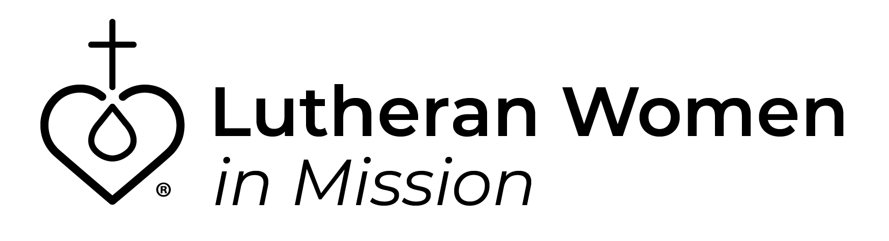

HOTEL DETAILS

Holiday Inn Belden Village
4520 Everhard Road NW
Canton, OH
www.IHG.com/CantonOH
(330)494-2770

- You are responsible for making your hotel reservations and must call the hotel directly at the number above to make your reservation.
- To get the special LWML room rate, tell them you are with the LWML Convention.
- Please be sure to give them the name(s) of your roommate(s).
- The hotel requires 1 credit card on file per room.
- Want to stay an extra day, no problem! Just let the hotel know when you register, and they’ll give you the special rate.
- Deadline to register is May 24th at 12:00 PM.
- Check-in 3:00 PM, Check-out 11:00 AM.
- Free parking on site.

Mission Statement

The mission of the LWML Ohio District is to assist each woman in affirming her relationship with the Triune God so that she is enabled to use her gifts in ministry to the people of the world.

Revised 2024 2 18
Printed 2024 2 16

